Emotional and Mental Analyst-EMA

**Prof. Nitin Dhawas1, Sujata Junare2, Dhanashree Kulkarni3, Durgesh Patil4, UtkarshBhangale5**

Professor, Information Technology, Nutan Maharashtra Institute of Engineering and Technology, Pune, India1

Student, Information Technology, Nutan Maharashtra Institute of Engineering and Technology, Pune, India 2

Student, Information Technology, Nutan Maharashtra Institute of Engineering and Technology, Pune, India 3

Student, Information Technology, Nutan Maharashtra Institute of Engineering and Technology, Pune, India 4

Student, Information Technology, Nutan Maharashtra Institute of Engineering and Technology, Pune, India 5

**Abstract**: Humans share a universal and fundamental set of emotions which are exhibited through consistent facial expressions, talking and writing/texting. An algorithm that performs detection, extraction, and evaluation of these expressions will allow for automatic recognition of human emotion in images, voice and text. Presented here is a hybrid feature extraction and facial expression recognition method that utilizes Viola-Jones cascade object detectors using Haar cascades extract faces and facial features, pyttsx3 which is a text-to-speech conversion library in Python and text2emotion support vector machine to determine emotion from text.

1. **Introduction**

Värnik claims India's adjusted annual suicide rate is 10.5 per 100,000, while the suicide rate for the world as a whole is 11.6 per 100,000.Every hour, one student commits suicide in India.

This present catastrophe of the pandemic has struck us with many disturbing events. Every soul on earth is terrified to go out in the vicinity. There is no other option but to clutch ourselves in the house and deal with the situation as deliberately as possible. In such situations, our mental health has been greatly neglected and has resulted in depression and psychological disorders. To relieve such distressed mindsets, one need to share his thoughts instead of clamming it inside. But in such introvert situations, one is hesitant and reserved to open up to somebody resulting in shyness and humiliation.

To overcome this dilemma, we are introducing a human like A.I. chatbot which recognises the emotions of the user by interacting with simple conversation and analyse what abrupt thoughts might lay in the user's mind. The user may name the bot anything he likes and shares his emotions, his thoughts, his psychological dilemmas with it and seek for solution. The bot will analyse what the user is dealing with and provide the user with comforting words, fun games, jokes, mind-soothing exercises, daily diary logs, daily mood tracker and much more stuff that will ease the user's nerves.

This will allow users to share their thoughts and worries without hesitation and shyness.

The user's data will be secure enough and can be manipulated by the user as per his liking. Interpersonal interaction is often times intricate and nuanced, and its success is often predicated upon a variety of factors. These factors range widely and can include the context, mood, and timing of the interaction, as well as the expectations of the participants. For one to be a successful participant, one must perceive a counterpart’s disposition as the interaction progresses and adjust accordingly. Fortunately for humans this ability is largely innate, with varying levels of proficiency. Humans can quickly and even subconsciously assess a multitude of indicators such as word choices, voice inflections, and body language to discern the sentiments of others. This analytical ability likely stems from the fact that humans share a universal set of fundamental emotions. Significantly, these emotions are exhibited through facial expressions that are consistently correspondent. This means that regardless of language and cultural barriers, there will always be a set of fundamental facial expressions that people assess and communicate with. After extensive research, it is now generally agreed that humans share seven facial expressions that reflect the experiencing of fundamental emotions. These fundamental emotions are anger, contempt, disgust, fear, happiness, sadness, and surprise. Unless a person actively suppresses their expressions, examining a person’s face can be one method of effectively discerning their genuine mood and reactions.

The universality of these expressions means that facial emotion recognition is a task that can also be accomplished by computers. Furthermore, like many other important tasks, computers can provide advantages over humans in analysis and problem-solving. Computers that can recognize facial expressions can find application where efficiency and automation can be useful, including in entertainment, social media, content analysis, criminal justice, and healthcare. For example, content providers can determine the reactions of a consumer and adjust their future offerings accordingly.

1. **Related Work**

As this topic is of interest in many fields spanning both social sciences and engineering, there have been many approaches in using computers to detect, extract, and recognize human facial features and expressions as well as emotions from face, speech and text. For example, these techniques are commonly used in AI assistants like Google assistant, Microsoft Cortana, Apple Siri, Samsung Bixby, etc. The recent android application Replika: My AI friend uses these features impressively.

1. **Methodology**

The detection and recognition implementation proposed here is a supervised learning model that will use the one versus-all (OVA) approach to train and predict the seven basic emotions (anger, contempt, disgust, fear, happiness, sadness, and surprise).

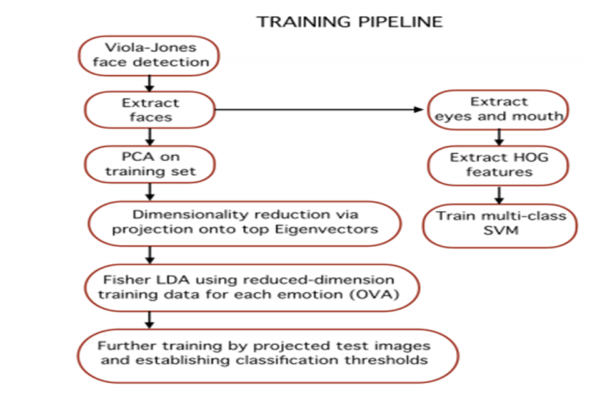

The overall face extraction from the image is done first using a Viola-Jones cascade object face detector. The ViolaJones detection framework seeks to identify faces or features of a face (or other objects) by using simple features known as Haar-like features. The process entails passing feature boxes over an image and computing the difference of summed pixel values between adjacent regions. The difference is then compared with a threshold which indicates whether an object is considered to be detected or not. This requires thresholds that have been trained in advance for different feature boxes and features. Specific feature boxes for facial features are used, with expectation that most faces and the features within it will meet general conditions. Essentially, in a feature-region of interest on the face it will generally hold that some areas will be lighter or darker than surrounding area.

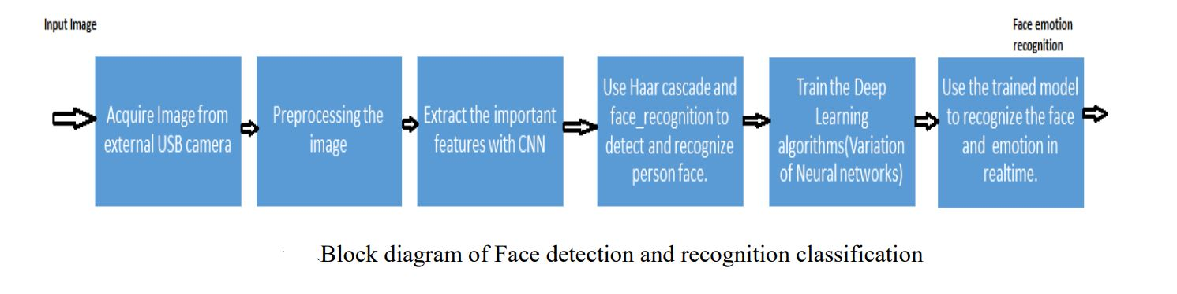

* This implementation by default detects emotions on all faces in the webcam feed. With a simple 4-layer CNN, the test accuracy reached 63.2% in 50 epochs.

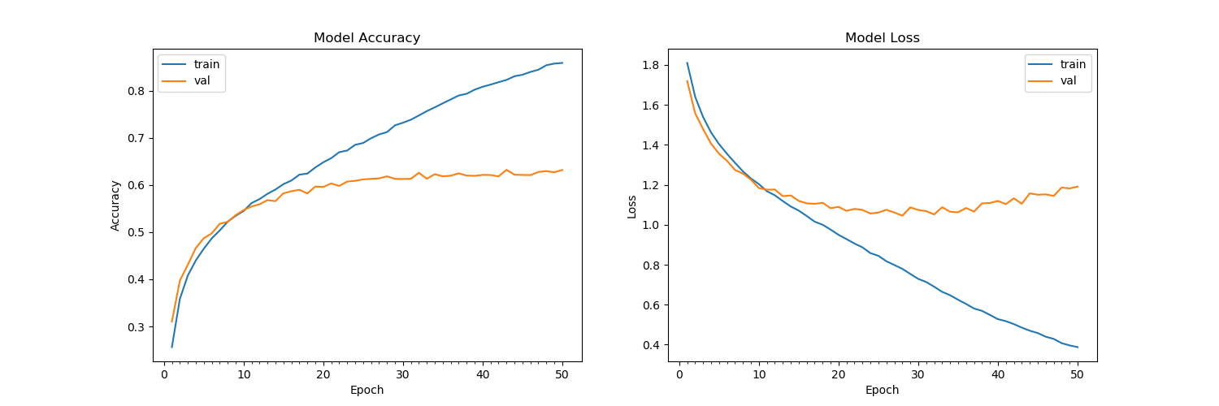

* First, the **haar cascade** method is used to detect faces in each frame of the webcam feed.
* The region of image containing the face is resized to **48x48** and is passed as input to the CNN.
* The network outputs a list of **softmax scores** for the seven classes of emotions.
* The emotion with maximum score is displayed on the screen.

The Real time face detection, recognition and classification is depicted in the figure. The captured image is bounded in a box and converted in to binary pattern to specify it as feature vector and stored in database. The images are trained to match the input image and also classify the expression of facial features as sad, angry, happy, disgust and neutral. In the training process, there are a total of seven steps which are represented below as loading dataset, pre-processing, augmenting the data as feature vector, building and compiling the design model, training and storing the feature vector and validating the test model.

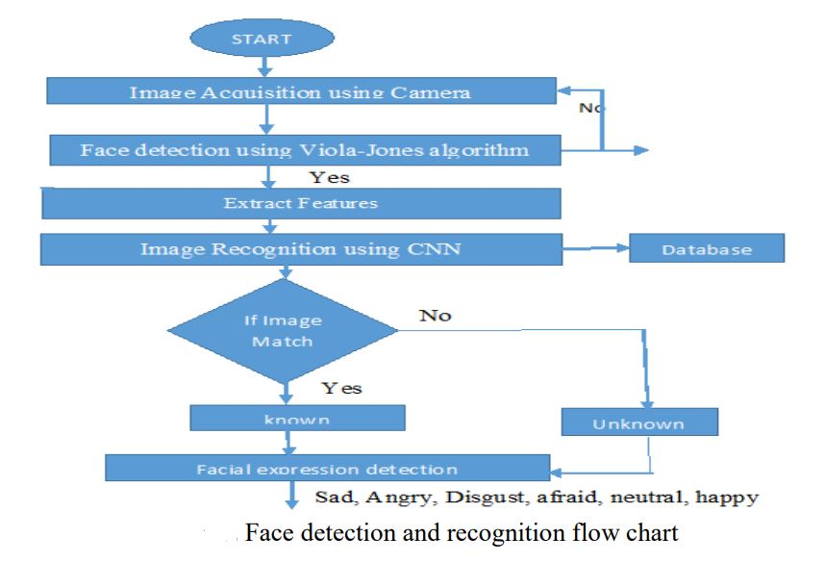

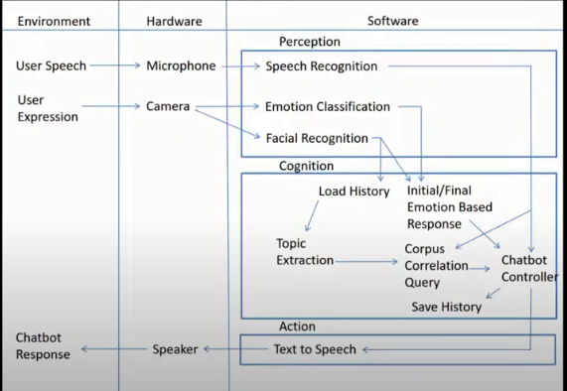

Emotion Detection and Recognition from text is a recent field of research that is closely related to Sentiment Analysis. Sentiment Analysis aims to detect positive, neutral, or negative feelings from text, whereas Emotion Analysis aims to detect and recognize types of feelings through the expression of texts, such as anger, disgust, fear, happiness, sadness, and surprise.

Text2emotion is the python package developed with the clear intension to find the appropriate emotions embedded in the text data. The research says that when the human is in the thinking process and he is damn sure about his statement then he will express his emotions in the right context of manner and it will be proper aligned in case of words expressing those emotions.

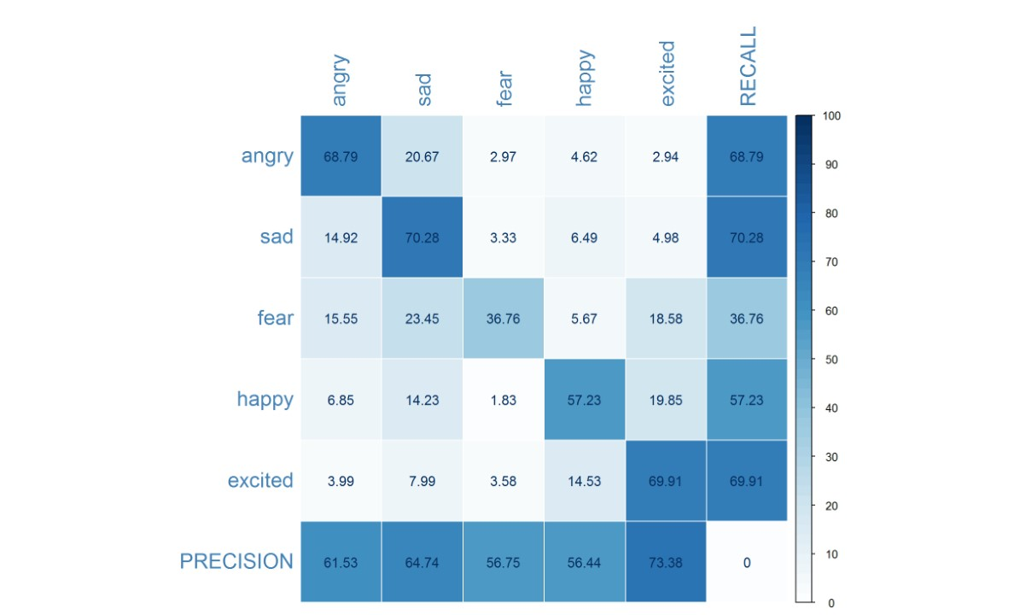

1. **Result and Discussion**

To deduct the emotion from the text, firstly we take the input through voice and convert it into the text using the Speech Recognition Package in python and then we try to detect emotions out of it. After the text has been converted then we use the program to detect emotion from it, the program cleans all the data means, firstly it removes all the blank spaces and not meaning full words from the sentence so that only the words which are needed to find emotion are left. Then we tokenize the words and use the word net to find the emotion from the sentence. Output is shown in the graphical as well as in coordinates form. As it ask for the input sentence from which the output has to be taken out, so we give the input and then the machine process the input which is given by the user and depict the output in the coordinated form in which the x-axis has the five emotions “Anger, Disgust, Fear, Joy, Sadness” and in the second line it shows how much the respective emotion is depicted in the input sentence. Same goes for the facial emotion recognition but with a bit more complex and predefined algorithm.

1. **Conclusion**

An image processing and classification method has been implemented in which face images are used to train a dual classifier predictor that predicts the seven basic human emotions given a test image. The predictor is relatively successful at predicting test data from the same dataset used to train the classifiers. We presented our work on text-based emotion classifications using different methods. The advantage of our system is that it is not only based on the single word in the sentence, but it also takes in to the surrounding words and then depicts the result. Moreover it considers users’ experiences thanks to the historical data component. Future will consist in comforting the efficiency of the proposed textual emotion deduction modality to existing system. And also to add more emotions other than those features we have used in this paper. The best feature extraction techniques may improve the classification performance.

**ACKNOWLEDGMENT**

Many thanks to Prof. Nitin Dhawas for guiding us throughout the project and Nutan Maharashtra Institute of Engineering and Technology for giving us chance to present this insightful paper.

**References**

1. Priya Dwivedi , *Face Detection, Recognition and Emotion Detection in 8 lines of code!*, towardsdatascience.com, April 3, 2019
2. Ekman, P. & Keltner, D. (1997). Universal facial expressions of emotion: An old controversy and new findings. In Segerstråle, U. C. & Molnár, P. (Eds.), Nonverbal communication: Where nature meets culture (pp. 27-46). Mahwah, NJ: Lawrence Erlbaum Associates.
3. Matsumoto, D. & Kupperbusch, C. Idiocentric and allocentric differences in emotional expression, experience, and the coherence between expression and experience. Asian Journal of Social Psychology (4), pp. 113-131 (2001).I.S. Jacobs and C.P. Bean, “Fine particles, thin films and exchange anisotropy,” in Magnetism, vol. III, G.T. Rado and H. Suhl, Eds. New York: Academic, 1963, pp. 271-350.
4. YasminaDouiji and HazarMousanifI-CARE - Intelligent Context Aware system for Recognizing Emotions from text
5. Agarwal A 2012 Unsupervised Emotion Detection from Text using Semantic and Syntactic Relations IEEE/WIC/ACM International Conference on Web Intelligence and Intelligent Agent Technology pp 346-353